- Setup Agent for kubernetes
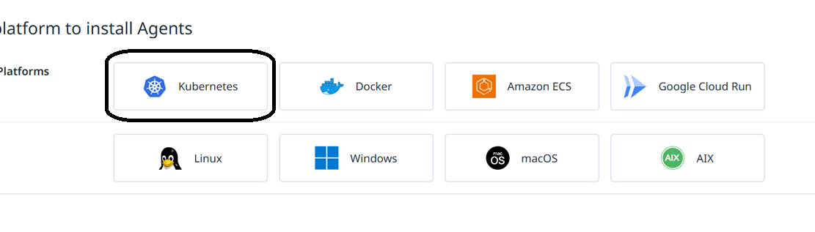

- Select Self managed

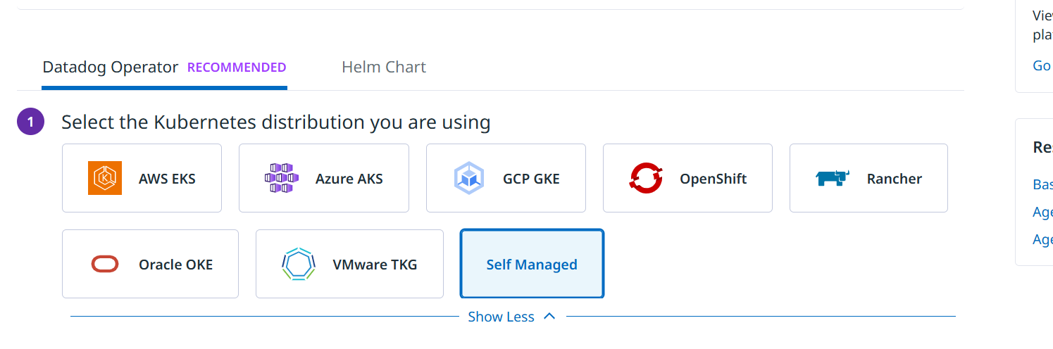
- Select api key
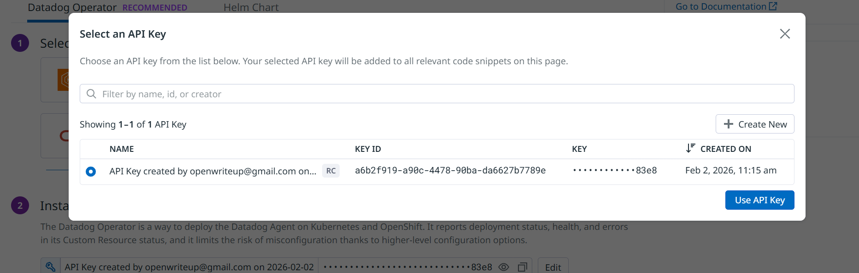

- Run the steps mentioned
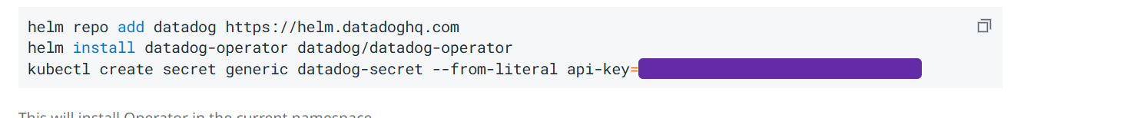

Enable option
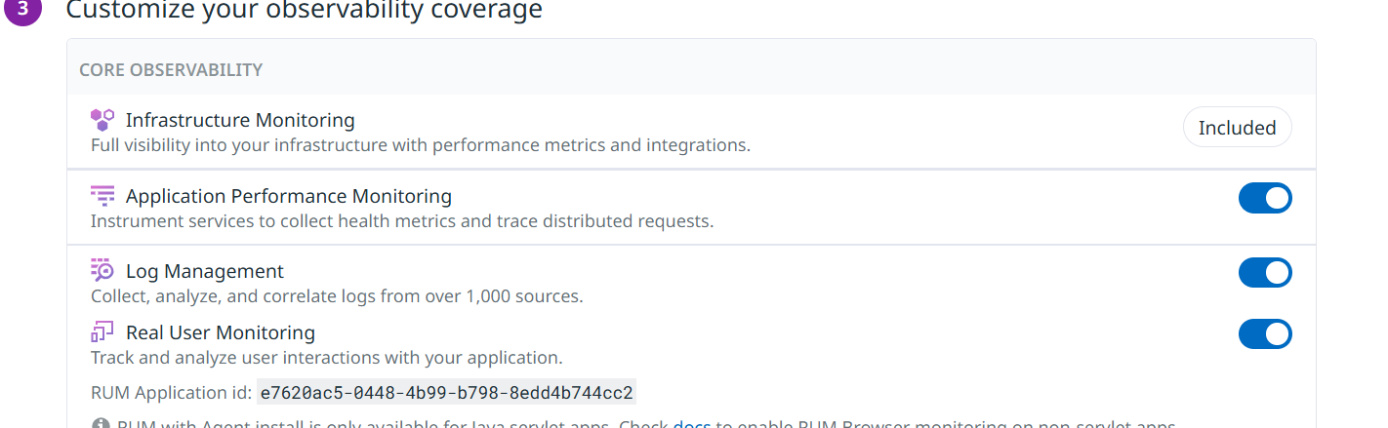

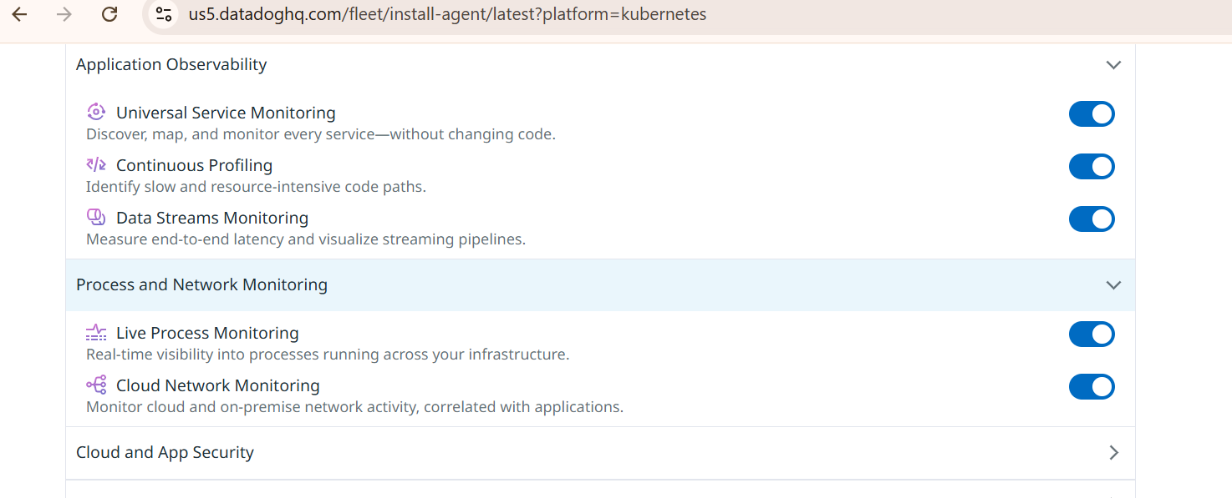

- Select env dev and cluster name: k8s-cluster
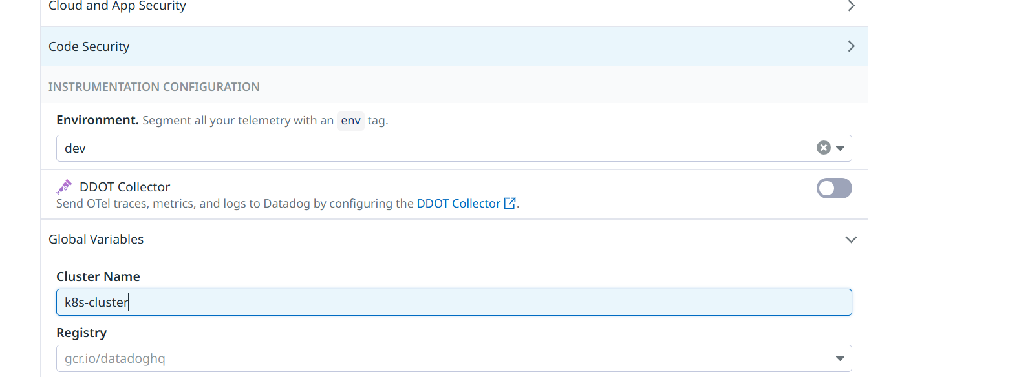

- Download the datadog agent yaml file
https://raw.githubusercontent.com/amitopenwriteup/datadog/refs/heads/main/datadog-agent.yaml
vi datadog-agent.yaml
#check is matching from the site
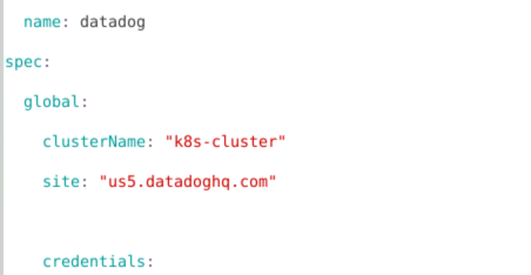

- Apply the yaml
kubectl apply -f datadog-agent.yaml
- Check the status
kubectl get pods -A

